Research: Robot Control from Unity

*Rene Bakx, June 2016*

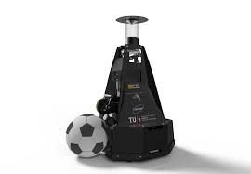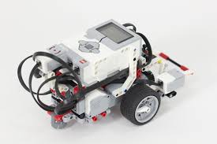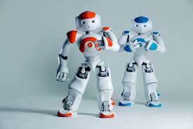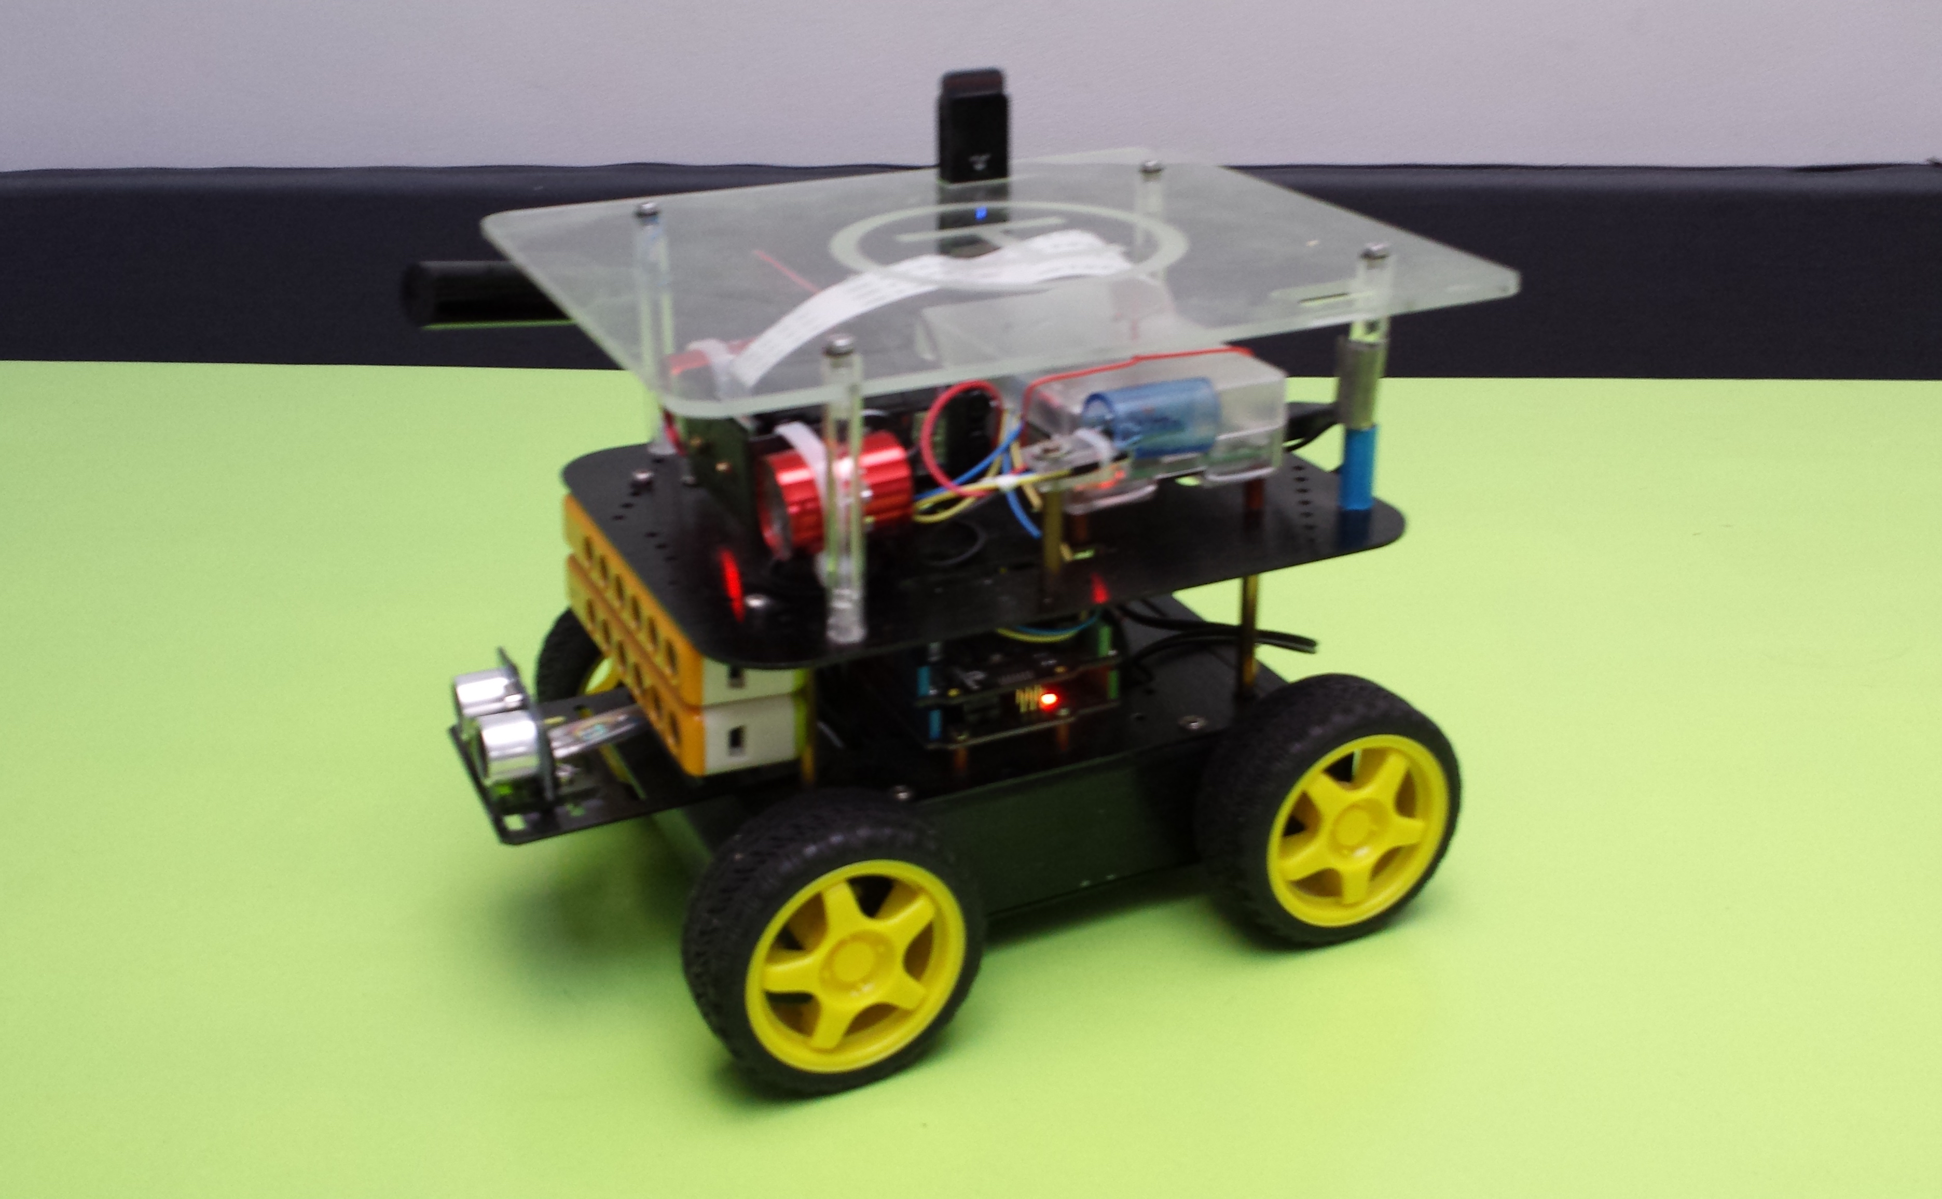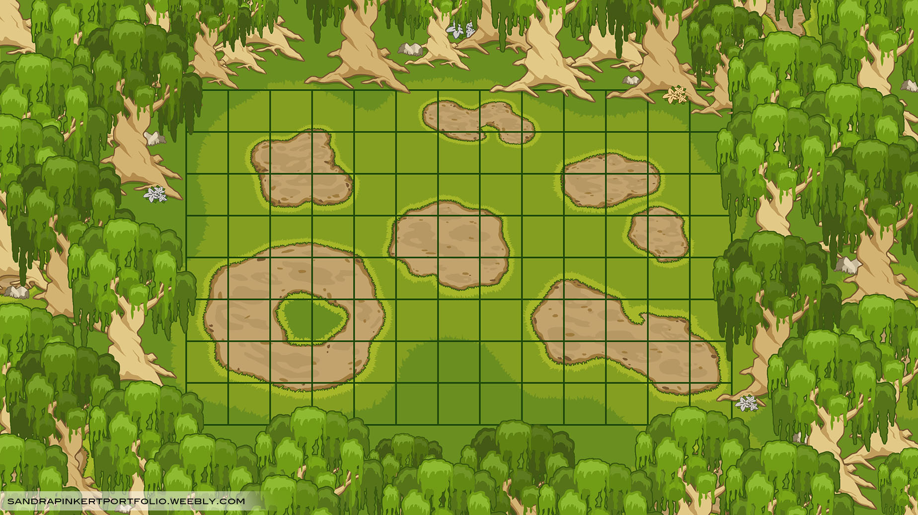

Abstract

Standard tools provided by the robot manufacturers work well for simple control of a robot like moving or simple navigation. These standard tools are less suited for giving a robot intelligent (AI) behavior. This requires:

* Knowledge of the robots surroundings or a world representation to enable planning ahead.
* Tooling which can use this knowledge to give a robot AI behavior.

These ingredients are typically available in games: there is a world representation and tooling available to give game characters AI behavior in this world. Examples of this tooling include inverse kinematics, navigation, pathfinding, behavior design and AI. The research is divided in two parts of which the first part is described in this report.

1. The first part of the research investigates whether using a game engine for controlling a robot has added value and is technically feasible. This research is done during the spring semester 2016 and it shows that using a game engine can have added value and is technical feasible. A prototype was built to prove technical feasibility.
2. The second part of the research will focus on giving a robot AI behavior using a game engine. This research will be conducted during the fall semester 2016. It will be documented in a separate report.

Glossary of Terms

AI Artificial Intelligence in the context of game AI

IDE Integrated Development Environment

OSI Open Systems Interconnect

ROS Robot Operating System

SLAM Simultaneous Localization And Mapping.

TCP Transmission Control Protocol

TRE The Robot Engine

UDP User Datagram Protocol

Unity Cross Platform game engine developed by Unity Technologies

Table of contents

1. Introduction 5

1.1. Context 5

1.2. Problem description 5

1.3. Hypothesis 5

1.4. Goal 6

1.5. Research questions 6

1.6. Constraints 6

2. Research question 1: Does control of a robot from Unity have added value? 7

2.1. Sub-question 1a: What are the criteria for having added value? 7

2.2. Sub-question 1b: Does our project meet the criteria for having added value? 7

2.3. Conclusions 8

3. Research question 2: Is control of a robot from Unity technically feasible? 9

3.1. Sub-question 2a: What are the criteria for the communication between a robot and Unity? 9

3.1.1. Communication Technology 9

3.1.2. Performance 9

3.1.3. Protocol 10

3.2. Sub-question 2b: Which communication technology can be used for the communication which meets the criteria? 10

3.3. Sub-question 2c: Which protocol can be used for the communication which meets the criteria? 10

3.4. Prototyping 11

3.4.1. Design decision: Which roles do a robot and Unity have with the proposed protocol? 11

3.4.2. Design decision: Should the communication between a robot and Unity be synchronous or asynchronous? 11

3.4.3. Prototype results 11

3.5. Conclusions sub-questions and prototype 12

4. Bibliography 14

# Introduction

## Context

This research is conducted at the ICT & Technology department of the Fontys University of Applied Sciences. At this department students learn about technology in which robotics is an important topic. The research described in this report is about controlling robots and is conducted in the spring semester of 2016.

## Problem description

Controlling a robot is mostly done by using programming tools available for the specific robot. For the Lego Mindstorms robot this is the Lego Mindstorms IDE, for the Nao robot this is Choregraphe. Other robots might run ROS (Robot Operating System) which is middleware containing packages e.g. for motion tracking, face recognition and SLAM (Simultaneous Localization And Mapping). These tools work well for moving a robot along its degrees of freedom, reading sensor data and simple navigation. However they are less suited for giving a robot more complex or 'AI behavior'. In this report we will use the term AI behavior where AI means 'Artificial Intelligence' in the context of game AI. This means it’s more the illusion of intelligence and thoughtful action than an actual intelligent reasoning driven behaviour.

## Hypothesis

To give a robot AI behavior requires:

* Knowledge of the robots surroundings or a world representation, to enable planning ahead.
* Tooling which can use this knowledge to give a robot AI behavior.

These ingredients are typically available in game engines which are development environments for games.: there is a world representation and tooling available to give game characters AI behavior in this world. Tooling typically includes inverse kinematics, navigation, pathfinding, behavior design and AI. This leads us to the hypothesis:

***Hypothesis:*** *Using a game engine to give a robot AI behavior has added value and is technically feasible.*

## Goal

Before letting students work on a project, it is good that there is confidence that the project has added value (‘makes sense’) and is technically feasible. The goal of this research is to get this confidence. It can be considered as pre-research and the outcome of this pre-research will determine whether or not to continue with the remaining part of the research project. This remaining part will deal with how to give robots AI behavior using a game engine and it will be conducted during the fall of 2016.

## Research questions

The research questions deal with two axes of confidence: added value and feasibility.

Only when both questions can be answered positively, student projects will be defined for the remaining part of the research project.

For answering the two research questions we will use research strategies as defined in [16], backed up by [5]. For clarity we will use the symbols below in the text to indicate which strategy is used.

    

## Constraints

The constraints for this research are listed below.

* As mentioned above this research is part of a bigger research project. The budget for the complete research is 100 hours. This includes:
  + Writing a research proposal.
  + Doing the pre-research described in this document.
  + Writing a Project Initiation document.
  + Organize and supervise student research projects.

It excludes:

* + The hours student will spend in the research projects.

For this pre-research no more than 40 hours can be spent, to leave enough hours for the other activities listed above.

* Because of the very limited time, available or easily obtainable hardware should be used. This will be a previously built robot [1] and the Unity game engine.

# Research question 1: Does control of a robot from Unity have added value?

To answer the question whether the project has added value or not (‘makes sense’), we first have to define the criteria to determine this. These criteria are still subjective, but we want to have a certain level of confidence that the project will lead to results which have added value.

## Sub-question 1a: What are the criteria for having added value?

Because we want to use multiple research strategies we define the following criteria:

1. Existing research projects, if any, indicate that controlling a robot from Unity can have added value. We will use the library strategy to answer this question.
2. Local game experts indicate that controlling a robot from Unity can have added value. We will use the field strategy for this question.
3. The community interested in robotics indicates that controlling a robot from Unity can have added value. We will use the showroom strategy for this question.

## Sub-question 1b: Does our project meet the criteria for having added value?

1. For the first criterion defined in 2.1 we did some research on available studies and projects. At first we checked official resources like [8] (HBO Kennisbank) and [13] (Scripties van de Nederlandse Universiteiten). Here projects on game engines combined with robotics are available, but with a different goal in mind, for example the simulation of a robot using a game engine.   
   We broadened the search by using Google and keywords ‘robot’, ‘robotics’, ‘game engine’, ‘Unity’, ‘Unreal’ in various combinations. We did find projects using game engine Unity for controlling a physical robot, most notably [4] and [18]. [4] describes a research project to control a lego robot from Unity. This research is done by associate professor Bartneck, C et al. at the University of Canterbury. A quote from this research which uses the term 'The Robot Engine' (TRE): “*This approach is so simple and powerful that we ourselves are surprised that it has not yet already been widely used. We believe that TRE has the potential to bridge the gap between engineers and computer scientists on the one side and psychologists and designers on the other*”.   
   [18] shows on YouTube project where a robotic hand is controlled from Unity.  
   However, both projects focus on direct control of a robot from Unity, while we want to want to focus on the AI behavior of a robot controlled from Unity. This because AI behavior is difficult to program using tools available for robots while it is well supported in Unity.
2. For the second criterion defined in 2.1 some colleagues from ICT & Game Design and Technology were informally asked the question “do you think it makes sense to control a physical robot from Unity with the purpose of giving the robot AI behavior”. The responses were along the following lines:

* “*Great idea, but response times might be a problem.*”
* “*Interesting idea, but you will only use a small part of Unity, maybe a tool like Blender is more suitable.*”
* “*Great, I get questions of students how to connect a Lego Mindstorms robot to Unity. Please let me know when you have results.*”

1. For the third criterion defined in 2.1 the showroom strategy is used: a one minute video showing a prototype and an explanation is posted on YouTube [3]. In the video there is the requests for comments. Since this is very recent, up till now there is one reaction:

* *“this is cool..... unity is more focused on games right, i mean 3d and other stuff, which are resource intensive. Can we have it running onboard the bot itself?*﻿”

## Conclusions

The conclusion of the sub-questions can be summarized as follows:

* There are some research projects done combining Unity and physical robots, but not many. Most of the projects focus of direct control of the robot, and not on the AI behavior.
* Local game experts give encouraging comments. The idea of controlling a robot from Unity is seen as an interesting idea with potential to have added value.
* The opinion of the community is coming in, but more time is needed to collect data.

All together it can be concluded: *Both existing research projects as local game experts suggest that controlling a robot from Unity can have added value.*

# Research question 2: Is control of a robot from Unity technically feasible?

To answer the question whether the project is technically feasible we first have to define the criteria to determine this. Because the technical feasibility of this project mainly depends on the communication between the robot and Unity, the sub-questions deal with the communication. After answering the sub-questions a prototype will be built for getting confirmation that indeed communication between the robot and Unity is possible.

## Sub-question 2a: What are the criteria for the communication between a robot and Unity?

For this question we will use common communication characteristics to define the criteria [12]. The criteria for communication can be categorized as follows:

### Communication Technology

For the physical connection of the communication we need a wireless connection, so the robot can move freely. For the wireless technology we need a technology which is available worldwide and which can deliver high performance. In addition the technology must be available on devices such as robots and laptops.

### Performance

Performance can be split up in bandwidth and latency.

#### Bandwidth*:*

Communication between Unity and a robot can take place at multiple levels:

1. At direct control level.  
   This means that every degree of freedom of the robot is controlled from Unity. For an humanoid robot this would mean that for example walking and keeping balance is controlled from Unity. For this a large communication bandwidth would be required, for example for the 3-axis accelerometer datastream.
2. At AI level.  
   At this level only the desired movement or other action is determined by Unity, like ‘move to the right’ or ‘give the distance to the object straight ahead’.

For this research we focus on communication between Unity and a robot on AI level. The idea is that more primitive operations like keeping balance or computer vision can better be done on the robot itself, as dedicated and optimized libraries for these operations are often available.

For the communication on AI level the required bandwidth will be low. For instance at a speed of 1 m/s and a positioning accuracy of 10 cm we need a data transfer every 0.1 s. For obtaining information of the objects around the robot it seems reasonable to use some kind of radar. For a 2D radar image with a 3 meter range and a resolution of 10 cm we need (2π x 3) / 0.1 ≈ 200 points per 0.1 s. For each point one byte is sufficient to specify the distance. In total this means a bandwidth of 16 kbit/s. For a 3D radar image this will increase to (π x 32) / 0.12 ≈ 3000 points per 0.1 s or 240 kbit/s. At a resolution of 1 cm this would increase to appr. 24 Mbit/s.

#### Latency:

For the speed and accuracy as discussed above, the maximum acceptable latency is about 0.1 s. When this latency is not met, it will limit the maximum allowable speed of the robot.

### Protocol

For selecting the communication protocol we define the following criteria.

1. The protocol must not constrain the data to be sent. Therefore we prefer a simple byte stream, as this can be interpreted as any type of data.
2. The protocol must have little overhead, as we want to maximize the performance.
3. The protocol does not have to be 100% reliable. When sensor data or a command is lost it will only lead to a temporary larger deviation between the actual situation and the representation in Unity. At the next information transfer this will be corrected again. This is preferable over a protocol which guarantees correct information transfer at the cost of real time behavior.

## Sub-question 2b: Which communication technology can be used for the communication which meets the criteria?

For this question we will use the library strategy to check whether existing technologies meet our criteria.

The only wireless communication technology which meets the criteria as specified in 3.1.1 is Wifi. With the Wifi 802.11n standard the practical bandwidth is very dependent of the circumstances and lies in the 15-50 Mbit/s range. The latency of Wifi 802.11n lies in the <100 ms range [7]. Both bandwidth and latency of Wifi 802.11n meet the performance criteria as specified in 3.1.2.

## Sub-question 2c: Which protocol can be used for the communication which meets the criteria?

For this question we will use the library strategy. As stated in 3.2 we will use Wifi. This wireless protocol operates at OSI layer 1 and 2. [20] shows the OSI model as depicted below including a number of existing protocols per layer.

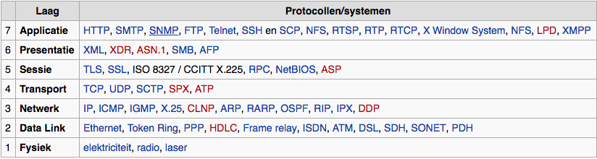

Figure OSI model with a number of the protocols from the TCP/IP stack [20]

Following criterion 1 as stated in 3.1.3 the protocols on layer 5-7 are not suited. This means we will use the Transport layer, which is the minimal layer required for transmitting byte streams. Following criterion 2 and 3 as stated in 3.1.3 we choose for the UDP protocol. This protocol is not 100% reliable but has a better real time behavior. According to [9] UDP is the best choice for multiplayer action games where occasional lag has to be avoided. This scenario resembles best our project where Unity is connected to multiple robots.

## Prototyping

 For a technology project like this involving software interfacing to hardware the best way to check if things really works as expected is building a prototype. Existing robot project [1] was used to make an actual connection to Unity using Wifi802.11n and UDP socket communication. In Unity a simple scenario was created in which the physical robot has to keep a distance of 50 cm from a box. For the implementation two design decisions had to be taken:

### Design decision: Which roles do a robot and Unity have with the proposed protocol?

According to 3.3 we will use the UDP protocol. This means there is a sever and a client where the client initiates the communication [11]. Because we want Unity to determine the behavior of the robot, Unity will act as the client and the robot as the server.

### Design decision: Should the communication between a robot and Unity be synchronous or asynchronous?

A game engine like Unity will display the game at a certain frame rate. Every frame Unity updates the state of all game objects. According to [15] updating the game objects happens on the main processing thread. When the communication between Unity and a robot is delayed this should not influence the frame rate or the communication to other robots connected to Unity. This means that communication between a robot and Unity should be asynchronous. For receiving messages this can be done using a callback method. For sending short messages it is also possible to send it synchronous because the send method will only block until the message is sent, regardless of whether the message arrives or not.

### Prototype results

Building the prototype took about 40 hours. This included adapting the existing robot project [1], implementing the communication and creating a simple scenario in Unity. A lot of practical issues had to be solved but the result was very satisfying. Not only it showed that communication between a robot and Unity worked but also it gave additional confidence that using Unity to control a robot can have added value.

**Measurements**

Measurements on the most critical performance parameter, latency, were done. The latency measured was appr. 0.5 s, but the major part of this 0.5 s can be attributed to a current limitation[1] in robot project [1]. This gives confidence that with optimization the performance criteria can be met. The project is maintained at GitHub [2]. For a YouTube video of the results, see [3].

## Conclusions sub-questions and prototype

The conclusion of the sub-questions can be summarized as follows:

* The criteria for the communication between a robot and Unity are divided in technology, performance and protocol criteria.
* For the communication we will use Wifi. Wifi 802.11n can deliver sufficient bandwidth for a 3D radar image with a resolution of 10 cm at a distance of 3 m with a frame rate of 10 Hz.
* At a latency of < 0.1 s the maximum speed of the robot will be 1 m/s. When the connection quality decreases then also the maximum allowed speed will decrease because of the increasing latency.
* For the communication protocol we will use UDP. The robot will act as the server and Unity will act as the client initiating the connection.
* A prototype is built which proved technical feasibility.

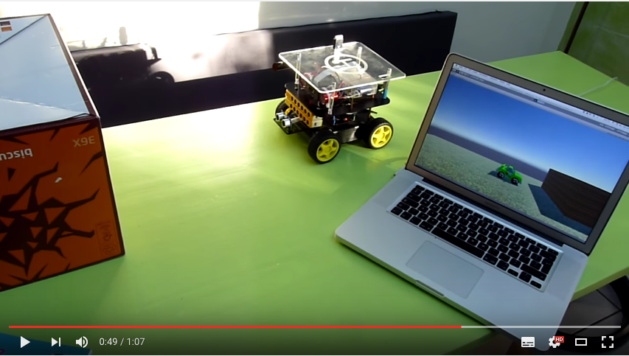

Figure . Short demonstration of the prototype on YouTube.



All together it can be concluded: *The control of a robot from Unity is technically feasible*.

# Bibliography

1. Bakx, R. (n.d.). DFRobot project. Retrieved May 17, 2016, from <https://github.com/rbakx/DFRobot>
2. Bakx, R. (n.d.). UnityRobot project. Retrieved May 17, 2016, from <https://github.com/rbakx/UnityRobot>
3. Bakx, R. (2016, May 8). Robot controlled by Unity. Retrieved May 11, 2016, from <https://www.youtube.com/watch?v=bVzXpRe1J_o>
4. Bartneck, C., Soucy, M., Fleuret, K., & Sandoval, E. B. (2015). The Robot Engine - Making The Unity 3D Game Engine Work For HRI. Proceedings of the IEEE International Symposium on Robot and Human Interactive Communication (RO-MAN2015), RO-MAN2015, 431-437. doi:10.1109/ROMAN.2015.7333561
5. Coppens, A., Jacobs, M., Jacobs, T., Niels, R., & Verhoeven, N. (2015, April). PROEVEN VAN ONDERZOEK. Retrieved from <http://www.ralphniels.nl/pubs/jacobs-proevenvanonderzoekboek.pdf>
6. Dyachenko, V. (2015, 13 december). C# + .NET: Minimalistic asynchronous UDP example. Retrieved from <http://yal.cc/cs-dotnet-asynchronous-udp-example/>
7. Grigorik, I. (2013). High Performance Browser Networking. Retrieved from <http://chimera.labs.oreilly.com/books/1230000000545/>
8. HBO Kennisbank. (n.d.). Retrieved May 17, 2016, from https://hbo-kennisbank.nl/nl/page/home
9. Lernö, C. (2014, 1 april). Game servers: UDP vs TCP. Retrieved from https://1024monkeys.wordpress.com/2014/04/01/game-servers-udp-vs-tcp/
10. Microsoft. (z.j.). Microsoft Developer Network. Retrieved May 8, 2016, from <https://msdn.microsoft.com>
11. M Kozierok, C. (2005, September 20). The TCP/IP Guide. Retrieved from <http://www.tcpipguide.com/free/t_TCPIPClientEphemeralPortsandClientServerApplicatio.htm>
12. Network performance. (n.d.). Retrieved May 8, 2016, from <https://en.wikipedia.org/wiki/Network_performance>
13. Scripties van de Nederlandse Universiteiten. (n.d.). Retrieved May 17, 2016, from <http://scripties.ned.ub.rug.nl/>
14. Swaen, B. (2012, November 19). Formuleren van onderzoeksvragen voor je scriptie. Retrieved May 27, 2016, from <https://www.scribbr.nl/starten-met-je-scriptie/type-onderzoeksvragen/>
15. Threading in Unity. (2011, 26 oktober). Retrieved May 11, 2016, from <http://answers.unity3d.com/questions/180243/threading-in-unity.html>
16. Turnhout, K. van, Craenmehr, S., Holwerda, R., Menijn, M., Zwart, J. P., & Bakker, R. E. N. (2013). TRIANGULATIE: EEN BASIS VOOR DE ONDERZOEKSLEERLIJN IN ICT EN MEDIA ONDERWIJS. Retrieved from <http://nioc2013.icalab.nl/wp-content/uploads/2013/12/nioc-paper-definitief-KvT.pdf>
17. Unity Technologies. (z.j.). Unity documentation. Retrieved May 8, 2016, from <http://docs.unity3d.com/>
18. Unity Technologies. (2015, April 17). Roll a Ball game. Retrieved May 8, 2016, from <https://www.youtube.com/watch?v=RFlh8pTf4DU>
19. Voicu, A. (2015, January 16). Unity 3D - Control a robotic hand with Leap Motion and Arduino. Retrieved from <https://www.youtube.com/watch?v=68jSTtdhiS0>
20. Wikipedia. (n.d.). TCP/IP. Retrieved May 8, 2016, from <https://nl.wikipedia.org/wiki/TCP/IP>

1. To control the GPIO pins on the Raspberry Pi root permissions are needed. For this a separate Python script was used for every GPIO action which takes about 0.5 s to start up.